Project Proposal

Scope
for
PlayAround
Version 1.0

Table of Contents
Contents
Abstract 1
1. Introduction 2
2. Problem Statement 2
3. Problem Solution/Objectives of the Proposed System 2
3.1 Objectives 3
4. Related System Analysis/Literature Review 4
5. Vision Statement 5
6. Scope 5
7. Modules 5
8. System Limitations/Constraints 7
9. Data Gathering Approach 8
10. Tools and Technologies 9
14. Mockups 10

Project Category: (Select all the major domains of proposed project)

C-Problem Solving E-Smartphone Application

Abstract

The sports industry is experiencing rapid global growth, with an expanding audience and rising revenue streams. However, in Pakistan, the sports ecosystem faces several challenges, such as limited infrastructure, inadequate investment, and a lack of formal training opportunities. Current systems rely heavily on in-person sports events and tournaments, which are hindered by accessibility issues, space limitations, health and safety concerns, logistical challenges, and the need for extensive resources. These limitations restrict the development and exposure of local athletes, coaches, and teams, preventing them from gaining recognition despite their potential and talent.

Introduction
Play Around aims to transform the sports industry by bridging the gap between athletes, coaches, and sports enthusiasts. In a world of diverse sports opportunities, this platform serves as a hub where users can explore, connect, and enhance their sports journey. The initiative’s foundation lies in addressing key challenges within the sports ecosystem, such as the limited accessibility of sports resources, lack of formal training opportunities, and reliance on traditional, in-person sports events that are often constrained by logistical and resource limitations. To overcome these barriers, we are developing a mobile application that provides a dynamic and accessible platform, redefining how users engage with sports communities and resources. For athletes and coaches, Play Around offers a streamlined, user-friendly interface to connect with teammates, find nearby facilities, join training sessions, and participate in custom tournaments. Athletes can track their skills, receive personalized training recommendations, and set performance goals. For coaches and organizers, the app provides tools to manage teams, schedule practices, and monitor individual and team progress. Play Around also fosters a community-driven sports experience with interactive features, allowing users to discover local events, participate in forums, and connect with sports shops for exclusive gear offers. Event streaming and webinars enhance engagement, feedback channels foster community insights, and partnerships with local businesses drive marketing opportunities. Sponsorship management opens doors for sponsors to engage with sports events, promoting a sustainable and accessible sports ecosystem that empowers athletes, coaches, and fans to shape the future of sports in Pakistan and beyond.

Problem Statement
In the absence of a dedicated online sports platform, athletes, coaches, and sports enthusiasts lack a centralized, accessible space to connect, collaborate, and advance in their sports journeys. Traditional in-person sports events and facilities come with limitations—restricted accessibility, space constraints, logistical challenges, health and safety concerns, and resource-intensive requirements—which hinder the growth of the sports ecosystem in Pakistan. Local athletes and coaches, often underfunded and with limited exposure, struggle to connect with relevant audiences, find nearby facilities, or access structured training resources and teams. The sports industry in Pakistan holds immense potential, yet it remains relatively underserved, lacking platforms that promote and celebrate the talent, teamwork, and dedication of Pakistani athletes and coaches. This gap limits the growth of the sports community, curtails opportunities for talent recognition, and stifles the potential for athletes to gain recognition and access global exposure. Play Around seeks to bridge this gap by offering a comprehensive online platform that empowers athletes, coaches, and sports enthusiasts to connect, train, and compete on a national and international scale.

Problem Solution/Objectives of the Proposed System
We are transforming the traditional sports landscape by creating Play Around, an innovative mobile platform that breaks down geographical barriers and provides a dynamic, accessible space for athletes, coaches, and sports enthusiasts worldwide. This platform addresses critical challenges in the sports industry, particularly the limited visibility and recognition of local talent in Pakistan.

Play Around is designed to cultivate an immersive and inclusive online environment where users can explore sports opportunities, connect with teammates and coaches, and participate in events from anywhere. By offering a dedicated space for athletes and coaches to showcase their skills, engage with the community, and access training resources, we aim to empower individuals to overcome the visibility gap that often hinders their progress. Ultimately, Play Around serves as a bridge between athletes and the wider sports community, revolutionizing how sports are experienced and managed. By creating an engaging mobile platform accessible to a global audience, we not only connect users with each other but also facilitate revenue generation within the sports ecosystem. Our focus is on empowering local athletes and coaches in Pakistan and beyond, providing them with essential tools and marketing strategies to extend their reach and achieve their goals in the sports industry.

Objectives
BO-1: Increase the number of athletes and coaches actively participating in the platform by 50%.
BO-2: Achieve a 30% reduction in the time it takes for users to discover and engage with local sports events, facilities, and training opportunities.
BO-3: Enable users to access multiple training session previews and facility tours before making a booking, enhancing their ability to make informed decisions and reducing the risk of unsatisfactory experiences.
BO-4: Facilitate the exchange of feedback and ratings on training sessions, facilities, and coaches available on the platform, encouraging user engagement and fostering interactions between users and coaches.
BO-5: Achieve an overall user satisfaction rating of 85% based on feedback and ratings provided by athletes and coaches within the first year.
BO-6: Implement a notification system that alerts users about upcoming sports events, tournaments, and training sessions aligned with their interests.
BO-7: Offer special promotions and discounts to users who book training sessions or facilities during specific events, enhancing the overall user experience.
BO-8: Develop an advanced recommendation system that utilizes user feedback on various training sessions and facilities to provide personalized suggestions.
BO-9: Enable users to manage their profiles, update personal information, and showcase their achievements and skills on the platform.
BO-10: Ensure the platform's accessibility and compatibility across various devices and browsers to cater to a diverse user base.
BO-11: Facilitate secure and seamless payment transactions between users and service providers, ensuring trust and ease of use on the platform.

Related System Analysis/Literature Review

Table 1 Related System Analysis with proposed project solution

Application Name | Weakness | Proposed Project Solution
Meetup | Meetup lacks a focused approach to sports, making it difficult for athletes to find dedicated events or training opportunities. | Play Around offers a sports-centric platform that connects athletes, coaches, and facilities, providing tailored features specifically for the sports community.
TeamSnap | TeamSnap can be complex and overwhelming for casual users, primarily focusing on team managers and lacking simple features for athletes. | Play Around features a user-friendly interface that simplifies navigation for all users, allowing athletes and coaches to easily access necessary tools without confusion.
Eventbrite | Eventbrite is primarily an event management platform, lacking specific tools for sports training and community engagement. | Play Around integrates community engagement features, such as feedback systems and forums, allowing athletes and coaches to interact and grow within their local sports communities.
Strava | Strava focuses mainly on tracking and social sharing for athletes but does not provide options for booking training sessions or facilities. | Play Around enables users to discover and book training sessions, coaches, and local facilities, streamlining the process of finding opportunities tailored to their sports interests.
Discord | Discord is great for communication but lacks features dedicated to sports management and training. | Play Around combines communication tools with sports-specific features, creating a centralized hub for athletes to connect, train, and improve their performance within a community context.
Facebook Groups | Facebook Groups can have limited functionality for sports organization and management, making it hard to track schedules and events. | Play Around allows athletes and coaches to manage their profiles, schedules, and bookings in one place, providing a comprehensive solution that promotes organization and engagement.

Vision Statement
For athletes, coaches, and sports enthusiasts who are seeking a comprehensive and engaging sports experience, Play Around is an innovative mobile platform that bridges the gap between participants and resources in the sports community. For athletes, it offers a user-friendly interface to discover training opportunities, connect with coaches, and engage with fellow sports lovers. For coaches, it provides tools to manage sessions, track performance, and receive valuable feedback. In the long term, our vision is to redefine how individuals interact with sports, foster a vibrant and inclusive sports community, empower independent athletes and coaches, and contribute to the sustainable growth and recognition of the sports industry globally.

Scope
The proposed platform, Play Around, aims to bridge the gap between athletes, coaches, and sports enthusiasts. For athletes, the platform provides a seamless registration process, allowing users to create profiles that highlight their sports interests, skills, and locations. The user-friendly interface enables athletes to explore a wide range of training opportunities, discover local coaches, and book sessions with ease. Athletes can engage directly with coaches, access their training history, participate in community forums, provide feedback and ratings on training sessions, and receive personalized recommendations based on their profiles. On the coach side, Play Around offers a dedicated dashboard where coaches can manage their profiles, schedule training sessions, and upload relevant details such as availability, pricing, and session types. Coaches can engage in real-time chat, host Q&A sessions, and gather valuable feedback from athletes to refine their coaching methods. The platform also includes a showcase section for coaches to highlight their qualifications, experience, and success stories, attracting potential clients. Additionally, Play Around features customizable notifications to keep users informed about upcoming training sessions, community events, and local sports activities that align with their interests. The mobile application integrates a secure payment gateway to facilitate smooth transactions for bookings, enhancing the overall user experience and generating revenue within the sports industry. Ultimately, Play Around seeks to redefine how individuals engage with sports, empower independent athletes and coaches, and create a vibrant and interactive sports community. It envisions a future where athletes can easily connect with resources, receive quality training, and improve their performance while coaches gain recognition and thrive in the ever-evolving sports landscape.

Modules
7.1 Module 1: User Registration, Profile Management, and Verification

FE-1: User registration and profile creation with personal details, sports expertise, location, and photos.
FE-2: Privacy settings for profile visibility and data sharing control.
FE-3: Admin management of user accounts, including approving/rejecting profiles.
FE-4: Admin handling of verification processes, including background checks for coaches.

7.2 Module 2: Matchmaking, Team Formation, and AI Integration

FE-1: Algorithm-based matchmaking for players and coaches based on sports interests, location, and skill level.
FE-2: "Swipe to Match" functionality for instant team, coach, or player suggestions.
FE-3: In-app messaging, real-time chat, and group messaging for teams.
FE-4: Admin monitoring of user matches, team formation, and communications.

7.3 Module 3: Facility and Coach Booking

FE-1: Find and book sports facilities or clubs, view ratings, pricing, and schedules.
FE-2: Search and book coaching sessions (personal or group) with nearby coaches.
FE-3: Admin approval of facility listings and coach profiles, and monitor bookings.

7.4 Module 4: Team Management and Tournaments

FE-1: Create or join teams, manage schedules for matches and practices.
FE-2: Track team performance, set goals, and monitor individual stats.
FE-3: Create and participate in custom sports tournaments with real-time updates.
FE-4: Admin moderation of team formations and tournament participation, including official tournament listings.

7.5 Module 5: Equipment and Sports Shop Integration

FE-1: Equipment recommendations and suggestions for nearby sports shops.
FE-2: In-app integration for purchasing sports gear from partner vendors, with user reviews and ratings.
FE-3: Admin management of shop partnerships and exclusive discount offerings.

7.6 Module 6: Skill and Performance Tracking:

FE-1: Track player and team skills, set personal goals, and monitor performance progress.
FE-2: View tournament results, team stats, and individual player metrics.
FE-3: Admin reporting and analysis of user engagement, performance trends, and team stats.

7.7 Module 7: Community Forums and Chats

FE-1: Join community forums to discuss sports strategies, tips, and local sports news.
FE-2: Discover local sporting events, clubs, and meetups based on location.
FE-3: Admin moderation of forums, community events, and local insights listings.
FE-4: In-app messaging for secure communication between players, coaches, and teams.
FE-5: Real-time chat with push notifications for message updates and event reminders.
FE-6: Group messaging for teams and training groups.
FE-7: Admin monitoring and moderation of communication channels to ensure safety and appropriate behavior.

7.8 Module 8: Analytics and System Maintenance

FE-1: Admin monitoring of app performance, system updates, and bug reports.
FE-2: Admin analysis of user engagement, bookings, and tournament participation trends.
FE-3: Generate reports for actionable insights to improve app features and user experience.

7.9 Module 9: Notifications and Feedback

FE-1: Sends real-time notifications for messages, team updates, booking confirmations, and event reminders.
FE-2: Delivers push notifications for upcoming matches, practice sessions, and tournament results.
FE-3: Enables the admin to send app-wide notifications for updates, offers, or important information.
FE-4: Integrates with calendar tools for easy scheduling and reminders.
FE-5: Allows users to rate and review players, coaches, teams, and facilities, with a transparent rating system highlighting top-rated profiles.
FE-6: Provides a feedback system for users to suggest improvements or report issues, which are reviewed by the admin team for app enhancements.

System Limitations/Constraints
LI-1: Users will need internet access to fully utilize the platform, which may limit accessibility for those in areas with limited or no internet connectivity.

LI-2: Ensuring the security of user data, payment information, and intellectual property of coaches and athletes is paramount. The platform must implement robust security measures to mitigate risks and protect sensitive information.

LI-3: The availability of training sessions and coaching resources may vary depending on individual coaches' preferences and scheduling capabilities. As a result, not all coaches may offer the same level of access or flexibility, potentially limiting user choices for training options.

LI-4: Obtaining real-time availability and booking information from coaches may pose a constraint. Coaches must actively update their schedules on the platform, and functionality may be limited by the accuracy and timeliness of these updates.

LI-5: While the platform aims to foster user engagement, it may still face challenges in encouraging consistent and active participation from both athletes and coaches, especially in maintaining ongoing interactions and community involvement.

LI-6: Attracting a critical mass of users and coaches to the platform may be a challenge. Effective marketing and promotional strategies will be crucial for driving initial adoption and sustaining growth.

LI-7: The platform must have mechanisms in place to verify the authenticity and quality of coaching submissions and user-generated content, as well as to prevent inappropriate behavior and ensure a safe environment for all users.

LI-8: The platform may rely on external services, such as payment gateways and cloud hosting, which could be subject to downtime or service interruptions, potentially affecting user access and experience.

Data Gathering Approach
The data gathering approach used by our team for Play Around includes the following methods:
User Surveys and Questionnaires: We will utilize both pre-launch and post-launch surveys to gain valuable insights into user preferences and feedback. These surveys will cover various topics, including age, gender, geographic location, sports interests, training preferences, and coaching styles. Pre-launch surveys will help tailor the platform to meet user expectations, while post-launch surveys will assess user satisfaction and identify areas for improvement.
Interviews: To gain a deeper understanding of the sports community, we will conduct interviews with athletes, coaches, and sports enthusiasts who are passionate about their respective sports and interested in the advancement of the sports industry. These interviews will be conducted through various means, including in-person meetings, phone calls, and video conferences. They will explore participants' experiences, challenges, and aspirations within their sports journeys.
User Analytics: We will implement user analytics tools to track user interactions and behaviors on the platform. This data will provide real-time insights into user engagement, popular features, and areas where users may encounter challenges, enabling us to refine and enhance the user experience.
Feedback Forms: Throughout the platform, we will incorporate feedback forms that allow users to share their thoughts, suggestions, and concerns. These forms will serve as a direct channel for users to provide input on their experiences, facilitating continuous improvement and responsiveness to user needs.

Tools and Technologies

Table 2: Tools and Technologies for Proposed Project
Tools  And  Technologies | Tools | Version | Rationale
Tools  And  Technologies | MS Visual Studio | 2023 | IDE
Tools  And  Technologies | MS Word | 2016 | Documentation
Tools  And  Technologies | MS PowerPoint | 2016 | Presentation
Tools  And  Technologies | Adobe Photoshop | v23.41.547 | Design Work
Tools  And  Technologies | Adobe XD | v50.0.12 | Design Work
Tools  And  Technologies | Figma | Online | Design Work
Tools  And  Technologies | Technology | Version | Rationale
Tools  And  Technologies | Postgresql | v16.0 | DBMS
Tools  And  Technologies | Django (Python) | v4.2 LTS | Backend framework
Tools  And  Technologies | Flutter | v18.0 | Front-end Development
Tools  And  Technologies | Python | 3.10 | Back-end Development

Mockups
Mockups for our proposed project are given below:

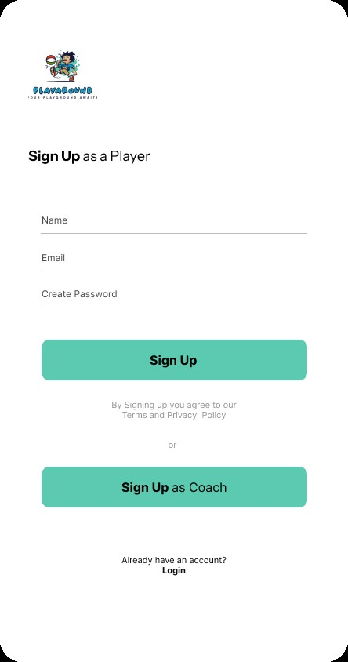

Figure 2 Loading Screen Figure 3 Login Screen

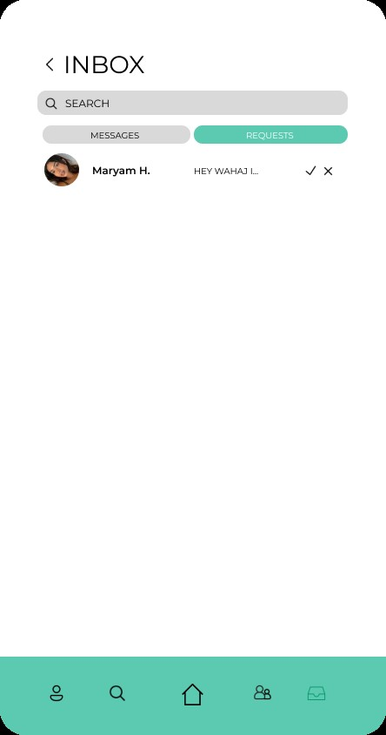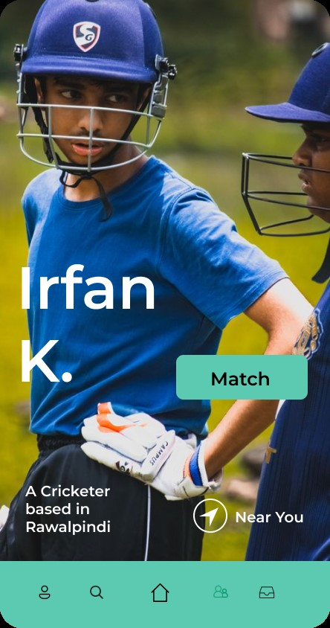

Figure 4 Messages Figure 5 Matching

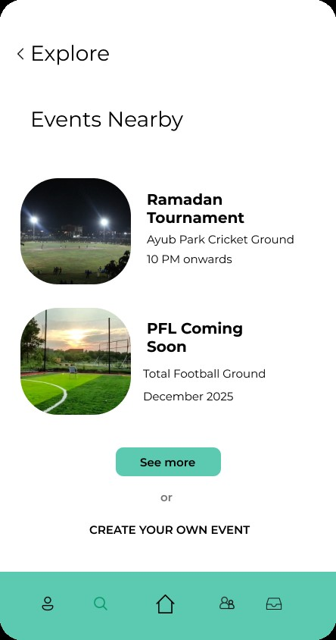

Figure 6 Explore

